# Sons of the American Revolution DAR Finder Report Form

|  |  |  |
| --- | --- | --- |
| SAR Applicant Name: |  | |
| SAR Applicant Chapter Name: | SAR Society: | |
| Referring DAR Member Name: |  | National DAR Number: |
| Referring DAR Member Chapter Name and Number: | Referring DAR State Society: | |
| First Line SAR Sponsor Name: |  | National SAR Number: |

It is imperative that the SAR maintains an accurate record of the DAR members who assist us in obtaining new members into the SAR. We encourage them to do so and reward their efforts by presenting them with SAR medals based on their level of participation. Individual SAR state-level society guidelines may be different. An accurate record must be kept by the first line SAR sponsors, all SAR chapters, and all societies, as a DAR Finder may assist with new SAR members at multiple chapters or even in other societies.

It is essential that the information in this form be recorded at the chapter and society levels, but this form must also be forwarded to SAR National Headquarters with the SAR applicant’s membership application. The Registrar at the SAR National Headquarters will then use these forms to determine the winner.

Medal of Appreciation Martha Washington Medal Daughters of Liberty Medal

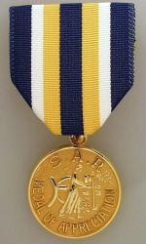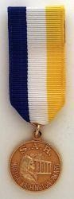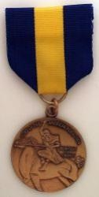

Form DAR.ver.1 Rev. 2016